**EEE361**

**ASSIGNMENT**

1. An expression for an electric field is given below

$E=20Cos\left(ωt-2x-3z\right)$ ay V/m

Is incident on a dielectric slab (Z ≥ 0) 5.5With µr = 1.0 and εr = 2.5 Find:

1. The polarization of the wave
2. The angle of incidence
3. The reflected E and H field
4. The transmitted E and H field

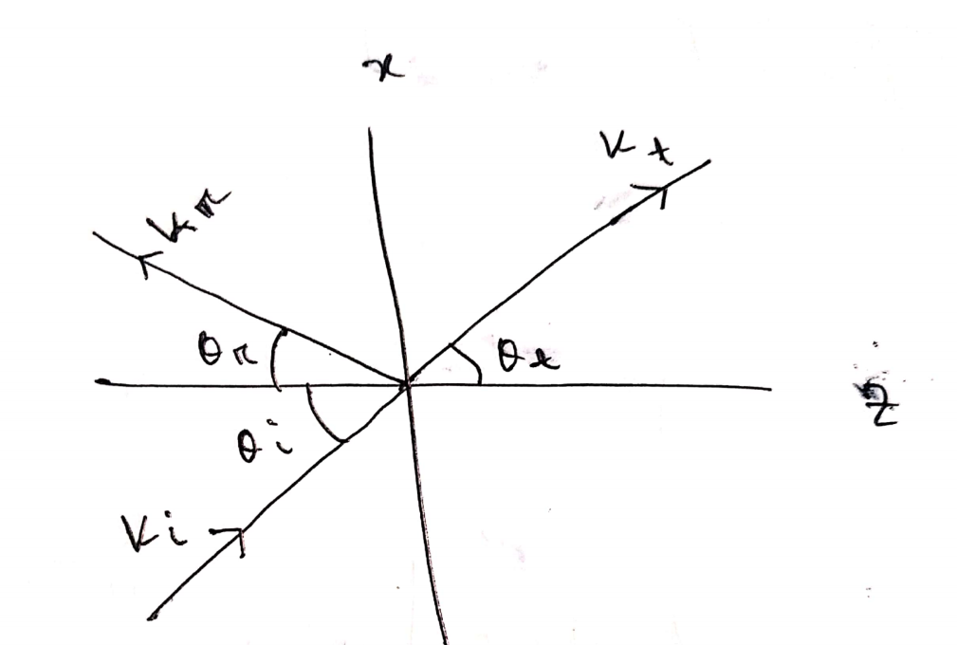

Fig: Problem 1

1. An expression for an electric field is given below

$E=20Cos\left(ωt-2x-3z\right)$ ay V/m

Is incident on a dielectric slab (Z ≥ 0) With µr = 1.0 and εr = 2.5 Find:

1. The polarization of the wave
2. The angle of incidence
3. The reflected E and H field
4. The transmitted E and H field

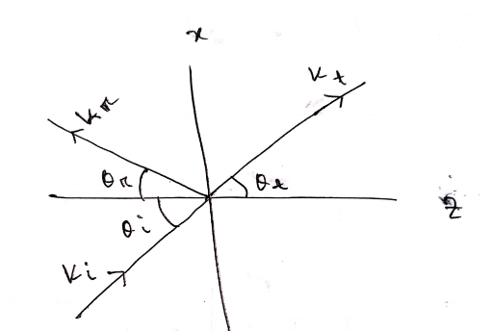

Fig: Problem 2

1. Suppose **E** fields and **H** fields are:

$$E = E_{0}e^{j\left(k.r-⍵t\right)}$$

$$H= H_{0}e^{j\left(k.r-⍵t\right)}$$

$Where$ k = kxax + kyay + kzaz and r = xax+yay+zaz

Show that $∇ × E = - ∂B/∂t$ can be expressed as K $×$ E = $μωH$ and deduce ak aE = aH

For the same fields:

Show that Maxwell’s equation in a source-free region can be written as

k.E = 0

k.h=0

k $×$ E = $μωH$

k $×$ H = $- μωH$

From these equations deduce ak aE = aH and ak aH = aE

1. a. let ${F }_{1}={ x }^{2}\hat{z}$ and ${F }_{2}= x\hat{x} + y\hat{y} + z\hat{z}$ calculate the divergence and curl of F1 and F2. Which one can be written as the gradient of a scalar? Find a scalar potential that does the job.

Which one can be written as the curl of a vector? Find a suitable vector potential.

b. Show that ${F }_{3}= yz\hat{x} + zx\hat{y} + xy\hat{z}$ can be written both as the gradient of a scalar and as the curl of a vector. Find scalar and vector potentials for this function.

1. For time varying fields: Find which if the following equations are not satisfy Maxwell’s Equation. Also state why the expression/s don’t satisfy Maxwell’s Equation? (Show Calculation)
$∇∙J + \frac{∂ρ_{v}}{∂t} = 0$

$∇∙D = ρ_{V}$

$∇∙ E = - \frac{∂B}{∂t}$

$\oint{H∙ dl} = \int{(σE + ε\frac{∂E}{∂t}} ) ∙ dS$

$\oint{B∙dS} = 0$

2. In free space $E=20Cos\left(ωt-50x\right)$ ay V/m, Find:
3. Jd
4. H
$ω$

5. The integral

$$a=\int_{S}{da}$$

Is sometimes called the vector area of the surface S. If S happens to be flat then |a| is the scaler area, obviously.

a. Show that a = 0 for any closed surface.

b. show that a is the same for all surfaces sharing the same boundary.

c. Show that $a= \frac{1}{2} \oint{r × dl}$ where the integral is around the boundary line. [Hint: one way to do it is to draw the cone subtended by the loop at the origin. Divide the conical surface up into infinitesimal triangular wedges, each with vertex at the origin and opposite side **dl**, and exploit the geometrical interpretation of the cross product.

1. In free space $E=20Cos\left(ωt-50x\right)$ ay V/m, Find:
2. Jd
3. H
$ω$

4. If any EM field fails to satisfy Maxwell’s Equation and the wave equation derived from them, then that is said to be nonexistent or not Maxwellian. Suppose the following expressions exist in charge free-regions. Find weather they are Maxwellian or not? State why the expression/s are not Maxwellian. (Show Calculation)
$A = 40 sin (ωt + 10x) a_{z}$

$B = \frac{10}{ρ} cos (ωt - 2ρ) a_{∅}$

$C = ( 3 ρ^{2} cot ∅a_{p} + \frac{cos ∅}{ρ} a_{∅}) sin ωt$

$D = \frac{1}{r} sinθ sin(ωt - 5r) a_{∅}$

5. Identify weather these functions satisfy the wave equations or not. Show all the calculations.
$50e^{jω\left(t-3z\right)}$

$sinω (10z + 5t)$

${ (x + 2t)}^{2}$

$\cos^{2}(y+5t)$

$sin x cos t$

$cos (5v + 2x)$

6. Given that F = x2yax – yay, Find

a. $\oint_{L}{}F∙dl$ where L is shown in figure below

b. $\oint_{L}{}(∇× F)∙ dS$ where S is the area bounded by L

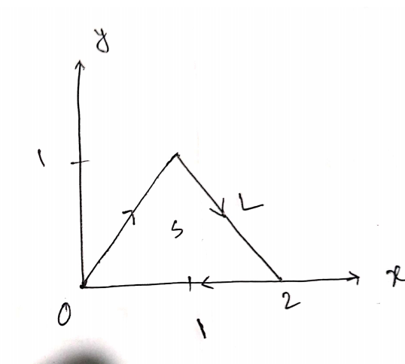

Fig: Problem 1

1. For time varying fields: Find which if the following equations are not satisfy Maxwell’s Equation. Also state why the expression/s don’t satisfy Maxwell’s Equation? (Show Calculation)
$∇∙J + \frac{∂ρ_{v}}{∂t} = 0$

$∇∙D = ρ_{V}$

$∇∙ E = - \frac{∂B}{∂t}$

$\oint{}H∙ dl = \int{}(σE + ε\frac{∂E}{∂t} ) ∙ dS$

$\oint{}B∙dS = 0$

2. Show that in a pure dielectric medium the E field $\vec{E} = 100 sin ( {10}^{8}t + \frac{x}{\sqrt{3}})$ is a valid solution to the wave equation. Also find the dielectric constant (Assuming the permeability is µ0) and the velocity of propagation.
3. In a dielectric medium (ε = 9 ε0, µ = µ0), a plane wave with

$$H = 0.2 cos ({10}^{9}t- kx-k\sqrt{8z} ) a_{y} A/m$$

Is incident on an air at z = 0 find

a. $θ_{r} and θ_{t}$

b. k

c. The Incident **E**

d. The transmitted and reflected **E**

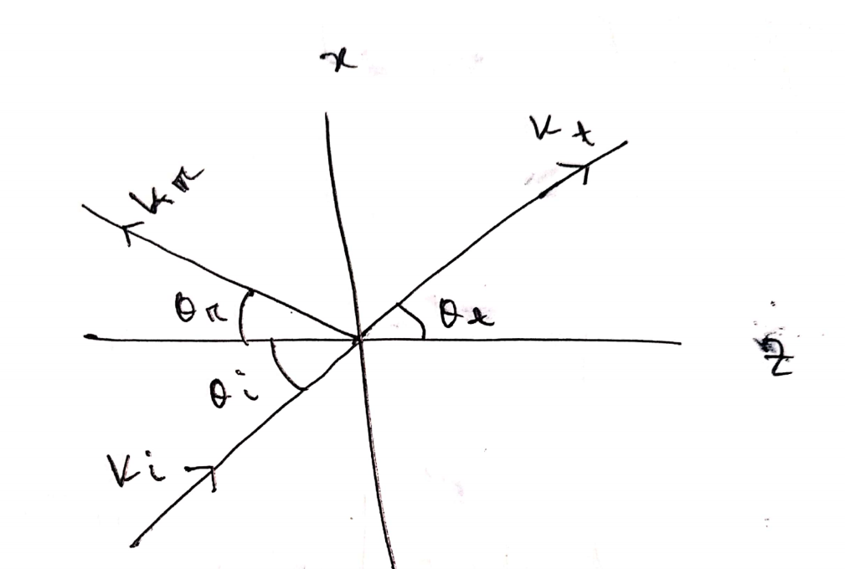

Fig: Problem 4

15. a. Explain the physical meaning of E = - $∇ V$.

To verify that E = yzax + xzay+ xyaz  V/m is truly an electric field, show that

b. $∇ × E = 0$

c. $\oint_{L}{}E∙ⅆl$ = 0, Where L is the edge of the square defined by 0 < x, y < 2, Z =1.